Experiment No.: 3
Title: Implement control structures and form validation; create a grading system based on user-entered marks.
Software/Tools Required: HTML5, CSS3, JavaScript, VS Code, Google Chrome
Theory: Control structures control the flow of a program using conditions such as if-else and loops. Form validation checks whether user-entered data is valid and within the required range. A grading system uses these concepts to validate marks and assign grades based on predefined mark ranges.
Output:
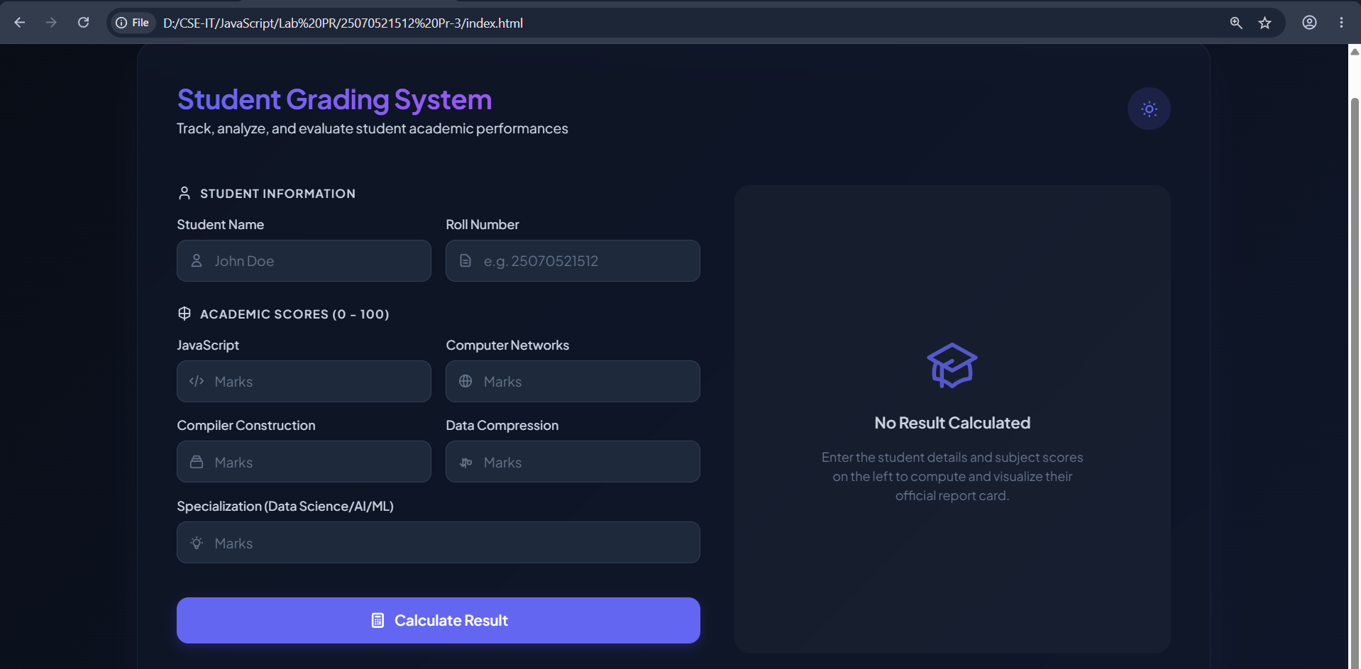
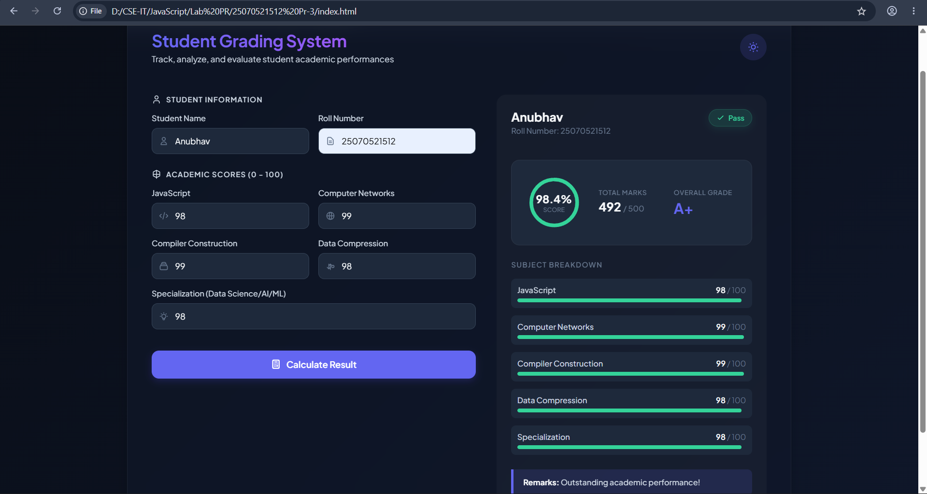

Result: A Successfully implemented control structures and form validation to accept user-entered marks and generate the corresponding grade accurately.
Conclusion: The experiment demonstrated the use of control structures and form validation; created a grading system based on user-entered marks.

